FIFO Page Replacement Algorithm
Write a C program to implement the FIFO Page Replacement Algorithm. The program
should take the number of frames and a reference string (sequence of page requests) as input. For each page in the reference string, determine if it results in a 'Page Hit' or a 'Page Fault'. Display the state of the frames after each request and calculate the total number of page faults and hits.

Input Format
- The first line of input contains an integer representing the number of pages in the reference string.
- The second line contains the page reference string as a sequence of integers.
- The third line contains an integer representing the number of available frames.

Output Format
The total number of Page Faults and Page Hits are displayed

Sample Input 1
7
1 3 0 3 5 6 3
3

Sample Output 1
Enter number of pages in reference string: Enter the reference string:
Enter number of frames:

Total Page Faults: 6 Total Page Hits: 1

How it works
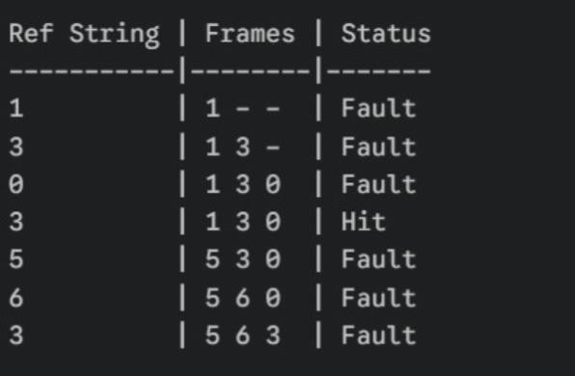

Code:
#include <stdio.h>
#include <stdbool.h>

int main() {
int n, capacity;

printf("Enter number of pages in reference string: \n"); scanf("%d", Cn);

int pages[n];
printf("Enter the reference string: \n"); for (int i = 0; i < n; i++) {
scanf("%d", Cpages[i]);

}

printf("Enter number of frames: \n"); scanf("%d", Ccapacity);

int frames[capacity];
for (int i = 0; i < capacity; i++) {
frames[i] = -1; // Initialize frames as empty
}
int pageFaults = 0; int pageHits = 0; int insertIndex = 0;

for (int i = 0; i < n; i++) { bool isHit = false;

// Check if page is already in frames (Hit) for (int j = 0; j < capacity; j++) {
if (frames[j] == pages[i]) { isHit = true;
break;
}
}

if (isHit) { pageHits++;
} else {
// Page Fault: Replace the oldest page

frames[insertIndex] = pages[i];
insertIndex = (insertIndex + 1) % capacity; pageFaults++;
}
}

printf("\nTotal Page Faults: %d", pageFaults); printf("\nTotal Page Hits: %d\n", pageHits);

return 0;
}

Input;
7
1 3 0 3 5 6 3
3

Output ;
Enter number of pages in reference string: Enter the reference string:
Enter number of frames:

Total Page Faults: 6 Total Page Hits: 1

LRU Page Replacement Algorithm
Write a C program to implement the LRU Page Replacement Algorithm. The program should accept a reference string and the number of frames. For each page request, identify whether it results in a Hit or a Fault. If a Fault occurs and the frames are full, replace the page that was accessed least recently. Display the frame status at each step and calculate the total number of Page Faults and Hits

Input Format
- The first line of input contains an integer representing the number of pages in the reference string. \
- The second line contains the page reference string as a sequence of integers.
- The third line contains an integer representing the number of available frames.

Output Format
The output displays the total number of Page Faults and the total number of Page Hits after processing the entire reference string using the LRU page replacement algorithm.

Sample Input 1
5
1 2 3 4 5
5

Sample Output 1
Enter number of pages in reference string: Enter the reference string:
Enter number of frames:

Total Page Faults: 5 Total Page Hits: 0

How it works
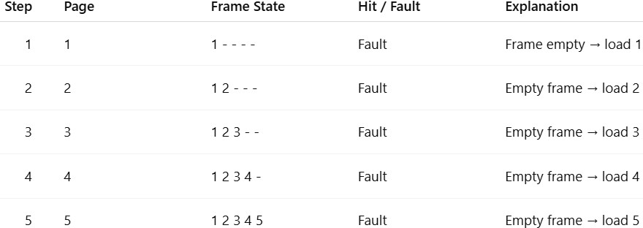

Code:
#include <stdio.h> scanf("%d", Cn);

int pages[n];
printf("Enter the reference string: \n"); for (i = 0; i < n; i++) {
scanf("%d", Cpages[i]);
}

printf("Enter number of frames: \n"); scanf("%d", Ccapacity);

int frames[capacity], time[capacity]; for (i = 0; i < capacity; i++) {
frames[i] = -1;
}

for (i = 0; i < n; i++) { bool isHit = false;

for (j = 0; j < capacity; j++) { if (frames[j] == pages[i]) {
counter++; hits++;
time[j] = counter; isHit = true;
break;
}
}

if (!isHit) {
if (frames[0] == -1 || frames[1] == -1 || frames[capacity-1] == -1) {
// Find empty frame
for(j = 0; j < capacity; j++) { if(frames[j] == -1) {
counter++; faults++;
frames[j] = pages[i]; time[j] = counter; break;
}
}
} else {
int pos = findLRU(time, capacity); counter++;

faults++;
frames[pos] = pages[i]; time[pos] = counter;
}
}
}

printf("\nTotal Page Faults: %d", faults); printf("\nTotal Page Hits: %d\n", hits);

return 0;
}

Input;
5
1 2 3 4 5
5

Output ;
Enter number of pages in reference string: Enter the reference string:
Enter number of frames:

Total Page Faults: 5 Total Page Hits: 0

